Supporting materials--outputs

RQ1-mDISCERN results comparison
Group | N | Mean | SD | Median | Mann_Whitney_U | MW_p | Welch_p
Health Source | 18 | 3.22 | 0.55 | 3 | 193.5 | 0.905 | 0.793
non-Health Source | 21 | 3.14 | 1.24 | 3 | 193.5 | 0.905 | 0.793

RQ2-DiD results
Outcome | Control Before | Control After | Treatment Before | Treatment After | DiD (pp) | β | Cluster SE | 95% CI | p
MCD | 6.96% | 5.86% | 17.82% | 8.43% | −8.29 | −0.0829 | 0.0224 | [−0.1268, −0.0390] | <0.001
Agreement | 37.17% | 21.59% | 16.72% | 11.63% | 10.49 | 0.1049 | 0.0232 | [0.0594, 0.1505] | <0.001

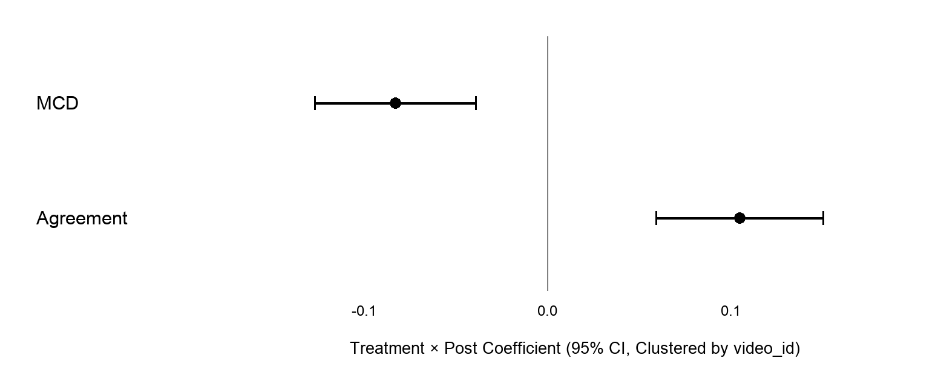
Figure. Main DiD interaction coefficients

